February 16, 2013

Hi Aminah,

I’m answering each of your questions under each one…

1. When were you diagnosed?

I was officially Dx in Canada in December of 2008, after I received my permanent residence status, including medical benefits.  I was married just over a year when I got the news that the "anxiety condition" that I had been suffering from since 2002 was actually Parkinson's Disease.

 2. What treatments are you doing now? how do they make you feel- physically and mentally?

I am not doing any treatments for PD besides taking my meds and being very active at my gym.  Attached is the article about me that was written by the director and me.  There are pictures too!  I feel great after I work out in the gym. The extra dose of dopamine makes me feel good, as does the fact that I can still handle all the physical demands I make of my body.

3. Are you taking any meds? Any allergic reactions?

Here is a list of the medications I take:

Lepo/carbodopa 100/25 1 1/2 tabs 6x day

Mirapex 1.5 mg 3x day

Entacapone 200 mg 6x day

Lisinopril (for just slightly high blood pressure) 5 mg 1x day

Zoloft (when needed for stress) 50 mg

I take Vit. D, especially in the dark Winter months and I have recently started to use Melatonen before bedtime, which really works to help me get a better night's sleep.

NO allergic reactions, but they do cause insomnia and make my heart pound and race if I get too stressed out. The Mirapex has the side effect of causing impulsive behavior in people who are prone to such behavior. Perhaps I can blame my love of the internet on that, but I think I'd be online as much as I am either way ☺

4. How did you feel when you got diagnosed?

I knew I had Parkinson's disease; by the time I was properly Dx-ed all the symptoms were there, so it was no surprise.  I felt grateful that I was able to go as long as I did without being medicated and I felt sad, as I knew that this condition would alter the course of my life and possibly leave me very disabled and even give me dementia. So I decided to fight my PD every inch of the way and to live in the present and count my blessings; that my symptoms are slow progressing, that I live in a kind country that provides for its disabled and sick with universal medical care, programs that pay for drugs and assistance and still allows one to work and even have money in the bank.

5. How has your life changed throughout the years?

It took me a lot of time and it was very difficult to do, but I finally came clean with my family and friends and told them of my condition and the ramifications of it. When I did this, I started to truly accept my condition.

I am happy in Toronto; it is an exciting place to live and I have made very good friends here, but my life is not the “happily ever after” story that I left El Paso to live. My new husband could not cope with my illness and his future role as my caregiver and he left me.  I went back to school to get the credentials I needed to teach, but now I only work part time, as a full time job is too demanding of the energy I need to have to work full time teaching.

I do not make a lot of money, but I get spousal support and ODSP (Canadian disability) to supplement my income.  The worse part of having PD is the lack of energy I have some times and the brain fog that sets in when my meds wear down.  Then I shake and stutter and have to search for the right words or forget what I wanted to to say until the next dose balances me out again.  I also walk with a walking stick now.  I don’t always need it, but on public transportation and on the icy streets in winter, it is a life-saver.

I am sad sometimes that I will probably never find anyone who would want to be with me because of my degenerative condition, so I have become fiercely independent. At the same time, I have become even more compassionate towards others and an advocate for the rights of the disabled in my building and in my community. I am also the co-moderator of an online Parkinson’s support group with members from all over the world: [www.MDJunction.com](http://www.MDJunction.com)

(go to the Parkinson’s group…I go by the name Claire on this site)

I will be attending the World Parkinson’s Congress in October in Montreal and plan to sit on several panels there.

I live in the present for the most part and I don't have time for grudges, anger or negative thinking. I have learned to set boundaries in my dealings with people and say “NO” to those who waste my time or stress me out. Life is precious and I want to have the best life I can for as long as I can...and this is the cock-eyed optimist in me.... until there's a cure or a way to reliably diminish both the motor and cognitive aspects of PD symptoms.

6. Any surgeries?

No, but I would be willing to try the deep brain stimulator if I ever need it and it is made available to me.

7. I see that you joined a boxing club, correct? Is this a coping mechanism, or did you have to do a physical activity?

Both. It is pretty well agreed upon that the symptoms of PD are best combated with physical activity and meditation, which I do as as well.   See the end of this letter or this link for my story about joining the gym and getting fit:

<http://99sudbury.ca/_blog/Gym/post/TheGym_is_Kicking_Parkinsons_Diseases_A!/>

My neurologist, who is an incredible person as well as an awesome Dr., has encouraged me to get moving and keep moving. When my Dr. gave me my Dx, I asked him if I was going to die from PD. He said, “No, but you will die with it.” So I had to decide how I was going to live and although the hand I've been dealt is a difficult one to play, I will play it as well as I can.  As I’ve said before, I may have PD, but it doesn't have me :)

MY MOTTOS…

"Once we accept our limits, we go beyond them."

Albert Einstein

'Be kinder than necessary, for everyone you meet is fighting some kind of battle.'

"The person who says it cannot be done should not interrupt the person doing it."

If the questions are to personal or you feel that you do not want to answer some of them. Let me know.

No worries, Aminah! Thank you for letting me have the opportunity to express myself and to let others know how this person with Parkinson's thinks.  Let me know what else I can do to help you and thank you for your prayers.... the prayers of my friends and family are sustaining and calming.

Be well,

Bonnie

Sent: Thu, Apr 4, 2013 4:53 pm

Subject: Re: Your questions about PD

Bonnie! How r u doing? Sorry it has been awhile since I have replied, been a busy lady lately! I am excited to tell your story in my presentation coming up. I have one more question.

    What were some of the symptoms you had that made you think you had P.D?

    Did you have to take any speech therapy or occupational therapy??

Wish you the best! and Praying :)

Aminah! <3

Hi Aminah,

So good to hear from you!  I was thinking that you must be pretty busy and I was hoping you'd write.

My symptoms, which when I look back, started in 2002, were very subtle.  I began to get stiff on my right side; my fingers, hand and arm and my leg and foot were effected and my movements became slower at times. Still, I had no idea that it was PD, as I thought PD was only  about  the shaking.  I was Dx-ed with a "nervous condition" and given clonipin and zoloft, which masked my other symptoms.  In 2007 I moved to Toronto, went off the meds and started to shake, lose my balance, fall a lot and slow down when walking or using my hands.  It was then that I  suspected that these were the symptoms of PD or that something was very wrong with my body.

I don't have to take any therapy right now, as my motor control, though diminished, is still good and I can exercise and can get around well.  My voice is getting weaker and sometimes my tongue gets lazy and I  slur or swallow my words.  I have to be very careful not to eat and converse at the same time, or I could choke on my food.  For these reasons I can see the need for speech therapy some time in the future.

Looking forward to reading your paper.

Hugs and love to all of the Orozco clan...

Bonnie

The medications you take, what is the purpose for each? Present on friday! i am so excited!

much love,

aminah

On Apr 15, 2013 10:28 AM, "Bonnie Lyons-Cohen" <[claireblc@aol.com](mailto:claireblc@aol.com)> wrote:

Hi Aminah,

Real quick cut and paste since.I'm at work:....

**Sinemet**

This is a combination product containing two medications: levodopa and carbidopa. It is used to treat Parkinson's disease. Levodopa helps to control the symptoms of Parkinson's disease by correcting the chemical imbalance in the brain that produces symptoms. Levodopa can be used alone, but adding carbidopa lowers the amount of levodopa that is required and may reduce some of the side effects that are associated with levodopa, such as nausea and vomiting.

**Mirapex**

[Pramipexole](http://www.webmd.com/drugs/drug-3680-pramipexole+oral.aspx) is used alone or with other [medications](http://www.webmd.com/drugs/index-drugs.aspx) to treat [Parkinson's disease](http://www.webmd.com/parkinsons-disease/default.htm). It can improve your ability to move and decrease shakiness (tremor), stiffness, slowed movement, and unsteadiness. It may also decrease the number of episodes of not being able to move ("on-off syndrome")

**Entacapone**

By inhibiting COMT enzymes that normally break down levodopa in the body, entacapone increases the amount of levodopa reaching the brain. This reduces the end-of-dose "wearing off" effect that some people taking levodopa may experience, thereby minimizing fluctuations in symptoms of Parkinson's disease.

Thank God these medications almost always work for me  (mostly good days, sometimes bad days) with minimal side effects!

I know you'll do great on your presentation..

Please send me a copy of what you've written.

Have a great week.....

Hugs,

Bonnie

Sent: Tue, Apr 16, 2013 7:21 pm

Subject: Re: Your questions about PD

One last favor i need from you. Can you please send me at least a two min video of you talking briefly about your everyday life and talking about How the physical activities have helped you so much. For example your boxing so people can get a feel what Parkinson disease really is. I want to put this in my presentation this Friday.

Oh and if you can explain what side effects you have with the pills you take. And how some days are better than others. And how/does that effect your work?

Thank you and much blessings.

Love Aminah.

**TheGym is Kicking Parkinson's Disease's A@#!**

Tuesday, November 20, 2012

By: David Vena

- Director, TheGym at 99 Sudbury

I want to share this story with everyone because it touches the very root of why both myself, and many fitness professionals get into this business in the first place. The idea of helping people get from their level 1 to their level 101 is truly the ultimate reward and truly inspiring for even ourselves.

I met a lovely lady named Bonnie the very first week that I came on board here at TheGym at 99 Sudbury.  Like most members at that time she had a list of suggestions and improvements for me to make, and as I braced myself for her list, I noticed her requests were a little different than the norm. She had asked me:

*“Is there a possibility for you to put highly visible tape strips on all of the edges of the stairs- throughout the gym area because I have a hard time with my coordination and it takes me a very long time to go up and down them because I battle Parkinsons disease”*

Heres a quick link discussing Parkinsons Disease in more depth: <http://www.livestrong.com/article/320930-parkinsons-disease-and-fitness/>

She also began to explain some of the other limitations she battles daily, such as standing, moving, bending and many of the things I/we tend to take for granted of on a daily basis.  Perspective.

I was both moved and sympathetic so immediately after our conversation, I google’d “reflective tape”!!!! But, about half way through my search I thought, what else can I do to help Bonnie?  Reflective tape cant be the ultimate solution?!?

The very next time I saw her, which was the next day- Did I mention this lady is a trooper!? We spoke again and I offered her a couple of personal training sessions with my head trainer Karin. Bonnie accepted my offer and shared her courage to fight the disease with me. What an inspiration. She immediately became hooked.  What followed could only be described as magic!

 Her progression BLEW MY MIND! No more than 6 weeks later she came to my office door, reached over her head- while standing on one foot and held her position perfectly still!!!! I thought to myself, "Can I even do that???" Lol my reaction was very “off the record” She truly unleashed the power within.

 It all boiled down to one fact: We had the perfect recipe for success. Bonnie’s determination and courage, Karin’s expertise,and our supervision was the perfect combination to help Bonnie kick Parkinson’s Disease in the A#$!

Here is her story in her own words…Way to go Bonnie you’re an inspiration to everyone!

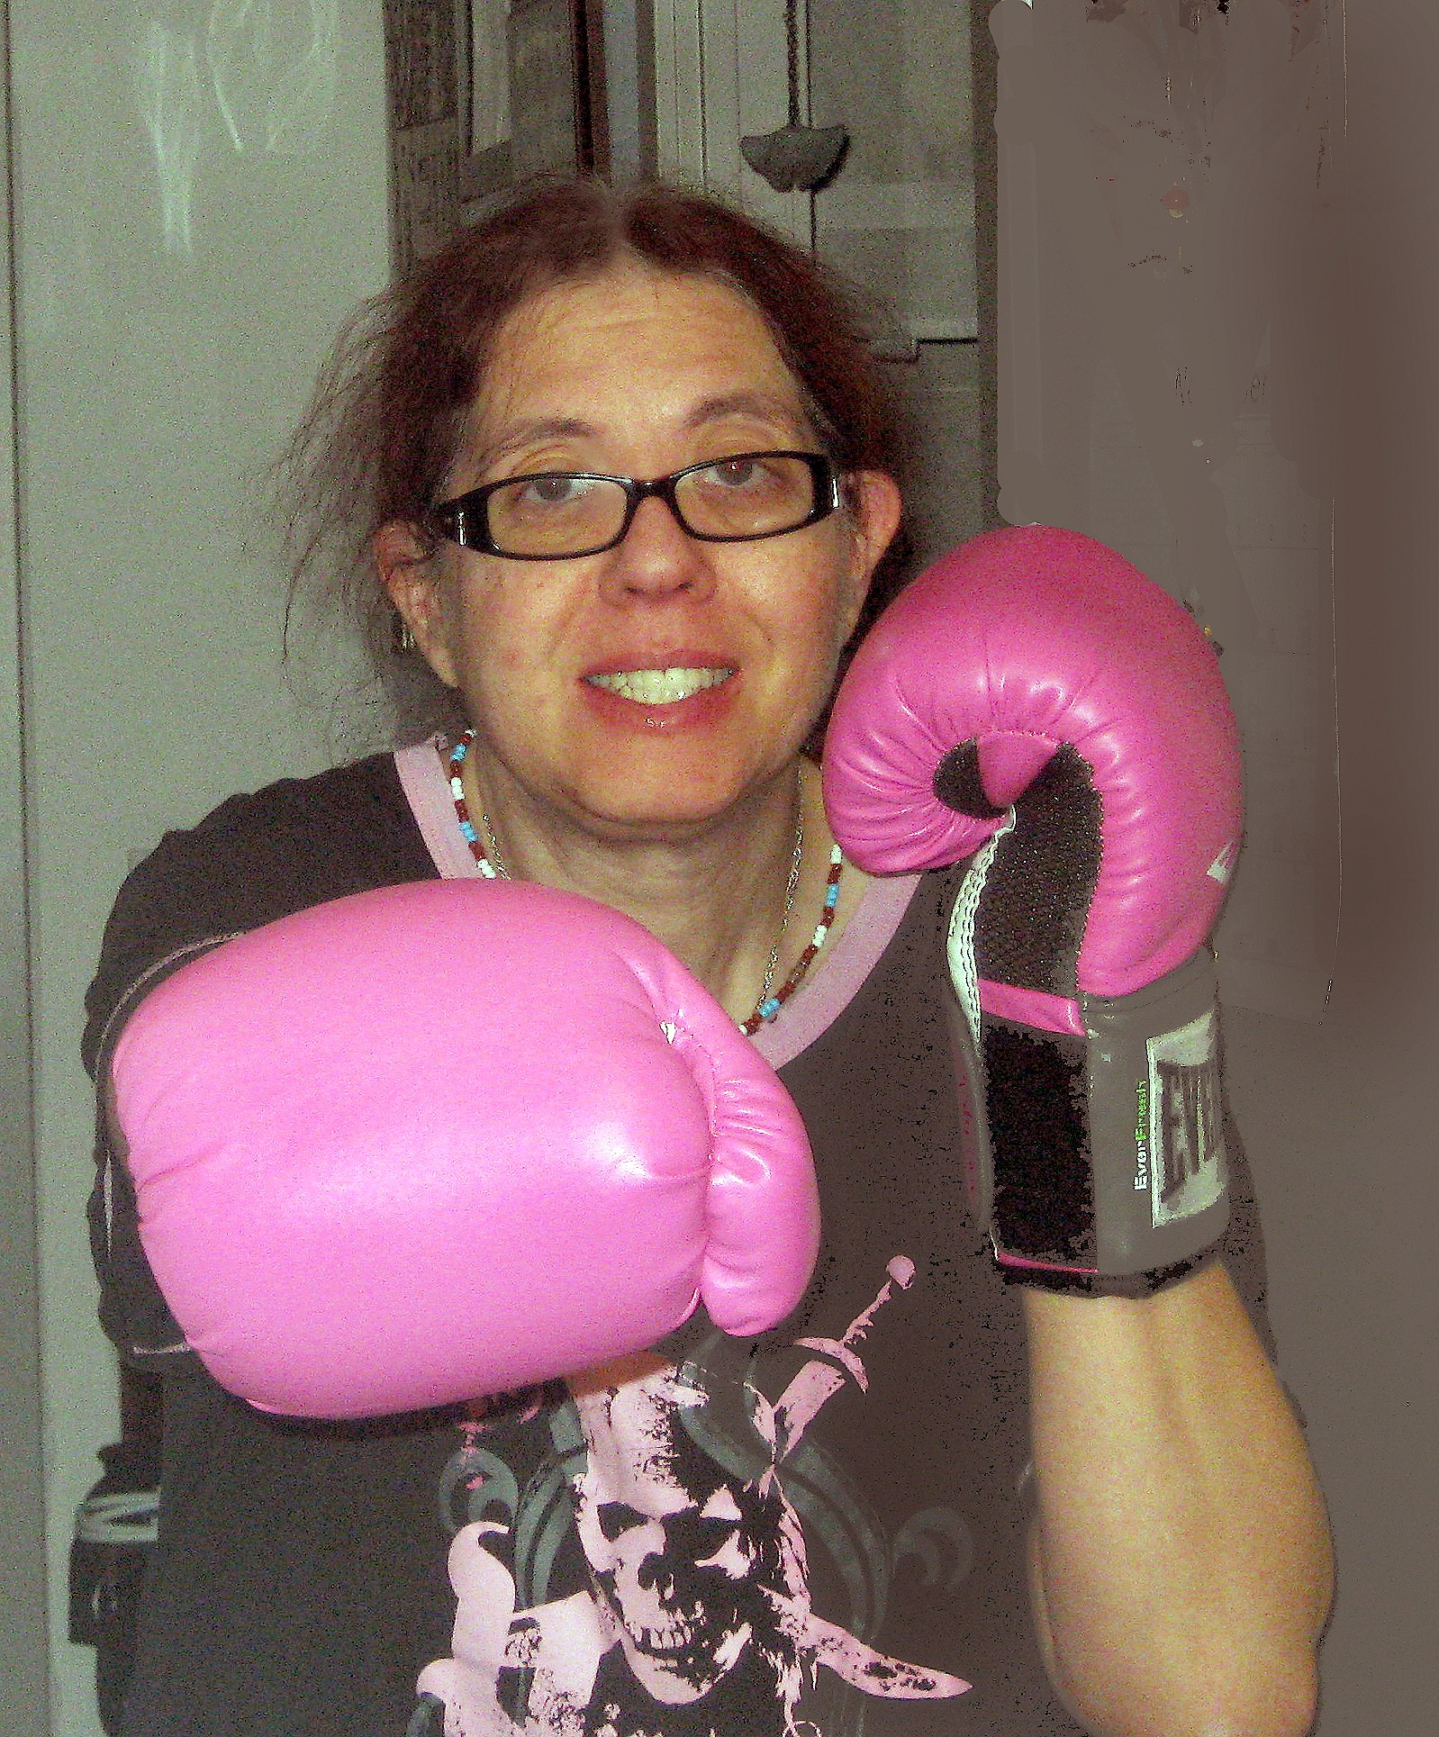

TheGym at 99 Sudbury and My Life Altering Experience

By: Bonnie Lyons-Cohen

“The person who says it can not be done should not interrupt the person who is doing it”…Tony Bahia- Personal Trainer and Martial Arts Specialist

I am 54 years old, I have been diagnosed with Parkinson’s disease since 2008 and I am on a Kung Fu team at 99 Sudbury Gym…that’s right…a Kung Fu team!!  I have been a member of 99 Sudbury Gym since 2007 and literally watched this gym being built around me.   Now I am building up in this gym.  From the start, I enjoyed Kaya McGregor’s Hatha Yoga classes and Viviane Palin’s Restorative Yoga class.  Those classes and the wonderful instructors kept me flexible and strong and still do, but I had slacked off on working out at the gym.

When my symptoms started to get worse and my sense of balance was diminishing, along with my sense of well being, my neurologist ordered me to get more active in the areas of weight lifting and cardio.  I read up on the studies that said that exercise protects the brain and the body from the effects of Parkinson’s disease.  I realized that I needed to make some changes in my life style and get back to the gym to get healthy again.

In January 2012, I started training with Karin Apold, Head Trainer at TheGym at 99 Sudbury. I had already lost a lot of confidence in myself and my fear and anxiety levels were very high. My sense of balance was terrible and I feared falling.  Karin was patient, but insistent that I get through all her planned exercises for me.  She helped to challenge me to be more confident in my movements and worked on my strength and balance.  At first, I couldn’t use some of the machines, even with no added weight.  Now, I have a regime to follow that has added muscle to my body and well being to my mind.

Then I met Tony Bahia, my martial arts Shifu.  I thought I’d be content only doing Tai Chi at 99, which is also wonderful for people with Parkinson’s disease, but Tony recognized my fighting spirit and invited me to join the Kung Fu classes. Tony also instills confidence in me and helps me with my movement and balance.  He has me jumping, spinning, kicking and sparring. I thought my feet would never leave the ground again and Tony makes me feel like, with practice, I can fly.  I might not move as fast as the rest of the class, but there is nothing I can’t do without his gentle guidance and firm teaching.

I work hard at TheGym at 99 Sudbury and I’m exhausted after my classes, but I also have a lot of fun here and more energy and peace of mind than I’ve had in a long time.  My membership at the gym and the wonderful teachers and trainers I work with have altered my life, bettered my life and have made it possible for me to live a healthier life. Being here has given me my life back.  I may have Parkinson’s disease, but it doesn’t have me.  Thank you to all at TheGym at 99 Sudbury!